

1. D
2. C
3. A

Divide the following phrases to a proper age group :

|  |  |  |  |
| --- | --- | --- | --- |
| toddlers | teenagers | adults | elderly |

fallible memory , confined to bed , , laid-back , live life to the full, grumpy , dare-devils , cherish life , strive for prosperity/wealth, carve a niche for himself, strive for ,

**Teenagers:**

vouch for, desist from , edge, pursuit , miss ,

Live On the ……edge…………………….. is full of fluctuations and uncertainty

Contrary to his peers he …misses………………………………………..alcohol and drugs

Despite the fact that he is in his adolescence I can ………………………………………..him he is such a humble and thoughtful person

Teenagers do most of the things with a bad ……………………………..

A lot of youth lose themselves in the …pursuit………………………….. of prosperity and wealth

Young people are light – hearted and airy . They ……………………themselves that they will live forever

When you are young you need to go extra mile not to ………………………..on opportunity/

Perspective, down, notwithstanding, stride, dent, light, articulate, trivial

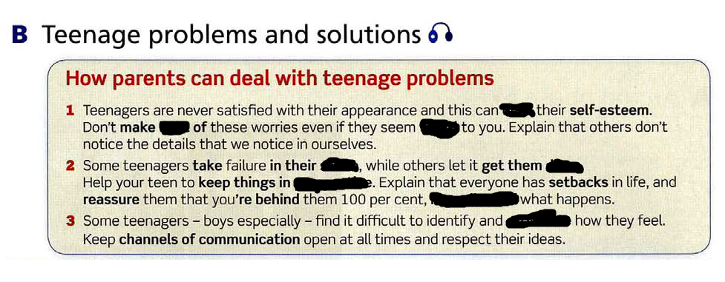

**Elderly**

**breadline, make , down , longevity , dim , purposeful , amends, hang , loop, behind , loses**

A lot of elderly people live on the ……………………………… , hardly …………………………….ends meet

Sometimes it is advisable to lose your hair …………………………when you are an adult or elderly to socialize with adolescents

He is in his 60 and yet suffering from memory …………………………He racks his brain trying to recall names of his relatives

Grandparents provide their grandchildren with unconditional love ready to fulfill every …………………………………..

………………………………………. of Polish people oscilates between 60 up to 90

When you speak with him you need to make ……………………………….. for his age as he tends to be grumpy and abrasive

Elderly people are not so much in the ……………………………..right now they don’t keep abreast with changing technology. They are a bit …………………………It is hard for them to get the ………………………..of modern devices

Even though he is 80 still leads quite …………………………………life

Elderly have pretty ……………………………………… view of how life looks like among teenaers right now

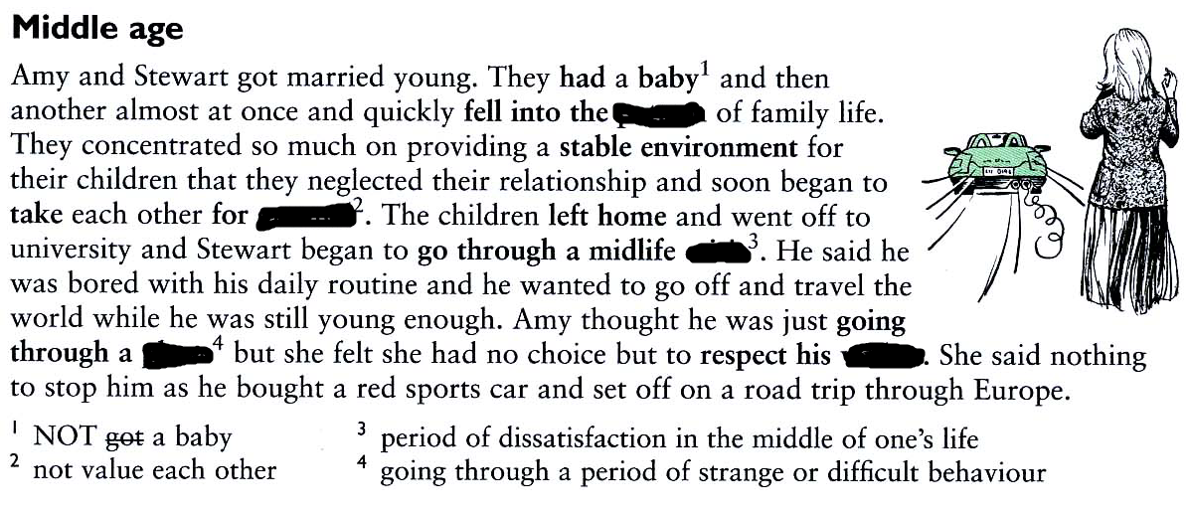

Pattern , crisis, granted, wishes, phase

Pattern, granted, crisis, phase, wishes

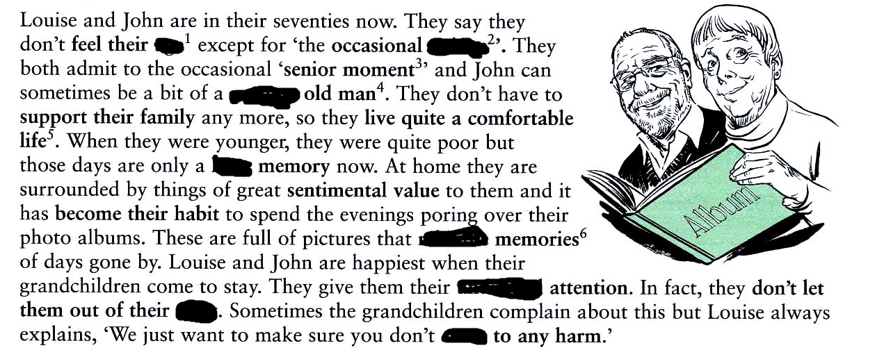

hazy, twinge, age, come, undivided, rekindle, enliven, grumpy

age, twinge, grumpy, hazy, rekindle, undivided, , come,